# Project Design Phase-I Solution Architecture

|  |  |
| --- | --- |
| **Date** | 08-11-2022 |
| **Team ID** | PNT2022TMID18685 |
| **Project Name** | Natural Disasters Intensity Analysis and Classification using Artificial Intelligence |
| **Maximum Marks** | 4 Marks |

**Solution Architecture:**

Solution architecture is a complex process – with many sub-processes – that bridges the gap between business problems and technology solutions. Its goals are to:

* Find the best tech solution to solve existing business problems.
* Describe the structure, characteristics, behaviour, and other aspects of the software to project stakeholders.
* Define features, development phases, and solution requirements.
* Provide specifications according to which the solution is defined, managed, and delivered.

# Solution Architecture Diagram:

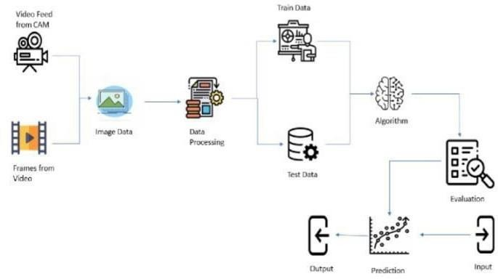

***Fig: Architecture and data flow of the Natural Disasters Intensity Analysis and Classification using Artificial Intelligence***